# CUSTOM DOCKERHUB REPLICATION RUNBOOK

Please follow this runbook for managing requests on [custom-dockerhub-replication](https://github.hpe.com/CaaSonHPE/custom-dockerhub-replication)

* Users needs to follow these [rules](https://github.hpe.com/CaaSonHPE/custom-dockerhub-replication#rules-to-follow-while-editing-the-requestyml-file) and [steps](https://github.hpe.com/CaaSonHPE/custom-dockerhub-replication#steps-to-raise-a-request) to raise a request for new images availability on the Production DTR
* Please review the PR and make sure that the images/tags requested are valid. To validate, go to [DockerHub](https://hub.docker.com/search?type=image) and search for the requested image

**Example:** Below is the requested image



On DockerHub search engine, look for **ansible/centos7-ansible** image, and for the tag **1.8** as shown below

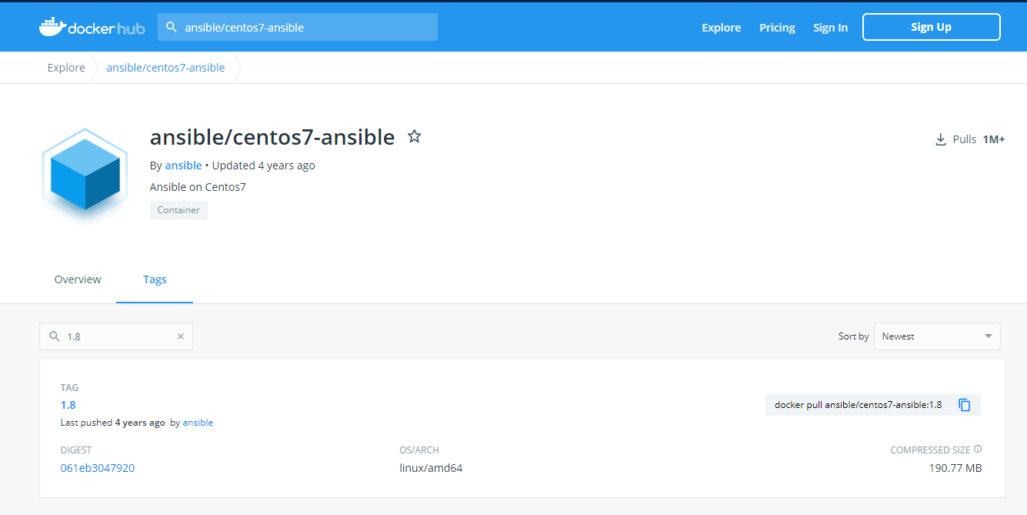

* Once the requested image/org/tag looks good, merge the PR and monitor the [Jenkins Build](https://jenkins.docker.hpecorp.net/job/CaaSonHPE/job/custom-dockerhub-replication/job/master/), otherwise please comment under the PR and let the requestor know that the image requested is not valid and it needs to be corrected
* Once the Jenkins Build is complete, validate that the image is available in the DTR by pulling it:

$ docker pull hub.docker.hpecorp.net/hub/<image name>:<tag name>

$ docker pull hub.docker.hpecorp.net/hub/<org name>-<image name>:<tag name>

**FYI:**

1. **How this custom-dockerhub-replication setup does is not running into the Pull Rate Limit Issue?**

DTR Platform Team purchased a DockerHub Team Subscription which provides a service-account for CI/CD activities. This service-account is being used in this setup to pull the requested images from DockerHub.

1. **Users requesting for multiple OS/ARC images available for an image version?**

Even though it is possible to pull and push a required OS/ARC version of an image to DTR, we ran into challenges when more than one OS/ARC versions of an image are made available as it appears on DockerHub.   
For any such use cases, App Team should pull the required OS/ARC version of that image and push it to their private repository on DTR.

1. **How are we making sure that all these requested images are in sync with the DockerHub?**

We are currently working on scheduling a job to pull all the requested images and push them to DTR occasionally. This will make sure that the requested images are in sync with the images on DockerHub.